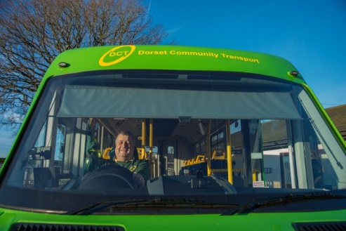

Saturday Bus Service Trial
Users of the Wednesday bus service will already be aware that Dorset Community Transport (DCT) is trialling a Saturday service which commenced on 20th January.

There will be two further services on Saturday 3rd February and Saturday 17th February after which there will be an assessment on the viability of a Saturday service.

Clearly the greater the support, the more likelihood it could become a permanent service.
For more details see the village website
www.littoncheney.org.uk ,bus shelter notice board or call 01258 287980 (DCT).

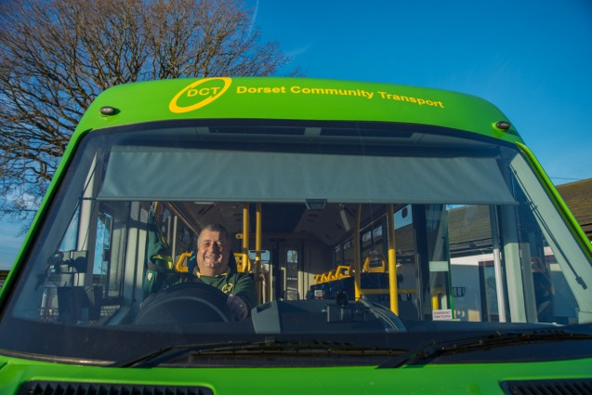

Saturday Bus Service Trial
Users of the Wednesday bus service will already be aware that Dorset Community Transport (DCT) is trialling a Saturday service which commenced on 20th January.

There will be two further services on Saturday 3rd February and Saturday 17th February after which there will be an assessment on the viability of a Saturday service.

Clearly the greater the support, the more likelihood it could become a permanent service.
For more details see the village website
www.littoncheney.org.uk ,bus shelter notice board or call 01258 287980 (DCT).

